**OUR WEBDESIGN PROCESS**

**Over the years, we have followed a sequence of steps to help achieve results for our clients!**

**Our 4 Step Process**

**Discover**

The discovery stage begins with desk research and background reading. This method allows us to engage directly with each customer, double-check any assumptions, and generate a detailed specification for the website's development. It enables us to obtain a better knowledge of the company, allowing us to make better design choices.

### Business

### We determine what constitutes a successful outcome by setting business and project objectives.

### Market

### In this case, the market's top competitor is being assessed. We looked at your competitor's website to discover what marketing strategies they were using and then used similar strategies in your marketing.

### Users

We find potential customers and do market and user research. We assist our current clients, then work to improve customer happiness by increasing user experience and service, as well as minimizing the time it takes to execute particular activities.

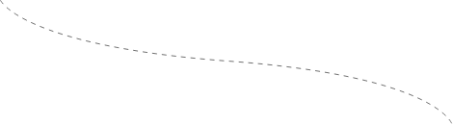

## Define

### Defining the scope of the project One of the most challenging aspects of the website design process is determining the scope. It's not always easy to grasp the scope, expectations, and resources. It changes throughout the process, which may have an impact on the quality of your project and result in more effort. We Define the scope of your project, such as the project duration, the total number of web pages, features you want on your website, and so on, and can assist you in achieving your website goals with little effort.

### Problem Statement

A problem statement is used to express what we intend to accomplish with our design. It is derived from a range of questions as well as many alternatives, ideas, perspectives, and ways of approaching the problem. We provide a solution that satisfies this demand, allowing you to please the user and provide a positive user experience.

### Information Architecture

### Our objective in information architecture is to classify material on a website or web application in a comprehensible, clear, and intuitive manner. After that, it must be structured in a user-friendly manner so that users may quickly discover what they want.

### User Journey

The pathways people take to attain their goals when exploring a website are referred to as "user journeys," and they are used in the design process to define all the potential ways a user might navigate through a site. To answer this, product or service designers must put themselves in the shoes of the client and aim to comprehend the full customer experience, from the moment they discover their product to the moment they use it.

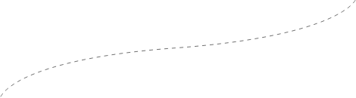

## Design

It's time to construct a sitemap and wireframe once you've established a clear focus. It will give you a rough sense of how your website will appear. Well! It's at this point that you may explain the connections between all of your website's pages and make changes to meet your objectives.

### Wireframes

### Wireframing is a crucial tool for the team to envision and plan for the site's success. Every online project should begin with adequate wireframing before moving on to graphic design.

### Visual Design

### Our graphic designers have a thorough knowledge of design foundations. Color theory and typography are examples of this. They must also know how to create brand assets (such as logos) and ensure that these assets are consistent across all brand designs.

### Prototyping

A website prototype will often go through several rounds of usability testing and receive input from stakeholders and users, during which time it will be continually modified until the project team is certain that it can go on to the next stage of development.



## Develop

### Finally, it's time to put your technological talents to the test and build a fantastic website. Well! This stage is simple since it incorporates all of the previous phases. Because there are millions of websites available online, it is critical to build a website that is error-free to rank highly on Google.

### Variety Of Stacks

It's a real challenge to pick the correct tech stack. The primary notion that should guide you is that the technology stack should be chosen based on the task specifications. Leave web creation to the professionals if you're not comfortable with it. Our staff is ready to assist you in determining the optimum technology stack for your needs.

### Meticulous Development

We meticulously plan our websites to ensure a strong presence. Having a dominant web presence implies that you have created a website with great care and intelligence. It forbids the use of any kind of deception.

### Cross-Platform Testing

We ensure that your website functions properly when viewed in a variety of browser-OS combinations, including common browsers such as Firefox, Chrome, Edge, and Safari, as well as any of the prominent operating systems.

## Our Tools

Design tools have the potential to affect the generation, expression, and perception of design concepts, so they must be used carefully. We've compiled a list of the most important and greatest tools to aid in the creation of stunning contemporary websites.

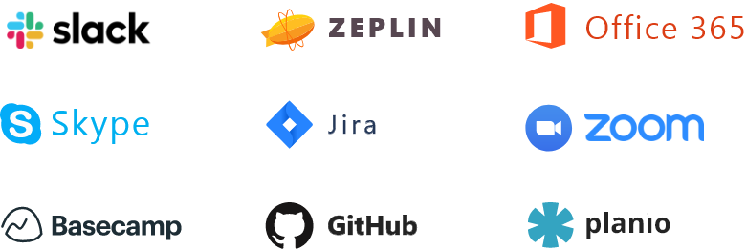

## Our Motto For Successful Website Design & Development

## Agility

Design tools have the potential to affect the generation, expression, and perception of design concepts, so they must be used carefully. We've compiled a list of the most important and greatest tools to aid in the creation of stunning contemporary websites

## ingenuity

We give extensive user experience models, overall information flow design, complete functional requirements, and technical documentation to customers so that the website is less expensive and faster to create than a less well-designed solution.

## reliability

"Giving the same outcome on successive tries" is how reliable is defined.

—Webster's Collegiate Dictionary

## About Our Web Design Agency



Key ideas are a leading website design firm that also offers web development, user interface design, software development, e-commerce, branding, and digital marketing services. We are regarded as one of the best full-service web design agencies in the world, offering a comprehensive range of website design and development services to our clients, large and small, ranging from user experience design (UX), information architecture, wireframe development, and web site SEO to graphic design, website coding, integration of various web tools and technologies, and content strategy, content creation, and development.

[**Read More >>**](https://keyideasinfotech.com/wp-content/uploads/custom/PKI-html/process.html)

© Copyright 2022. All Rights Reserved.

🌟 By Rahul Kumar 🌟